# Task Solution:- Oodles Technologies Pvt LtdOodles

# Git repository:

<https://github.com/OCTO01032020-araju/java-mysql-doc-compose.git>

* Indiameter-maven :- java springboot source code
* Dockerfile for Java Springboot
* Docker-compose.yml

**Command used:**

$Docker-compose up --build .

# 

**AWS Task**

# Created a dev VPC

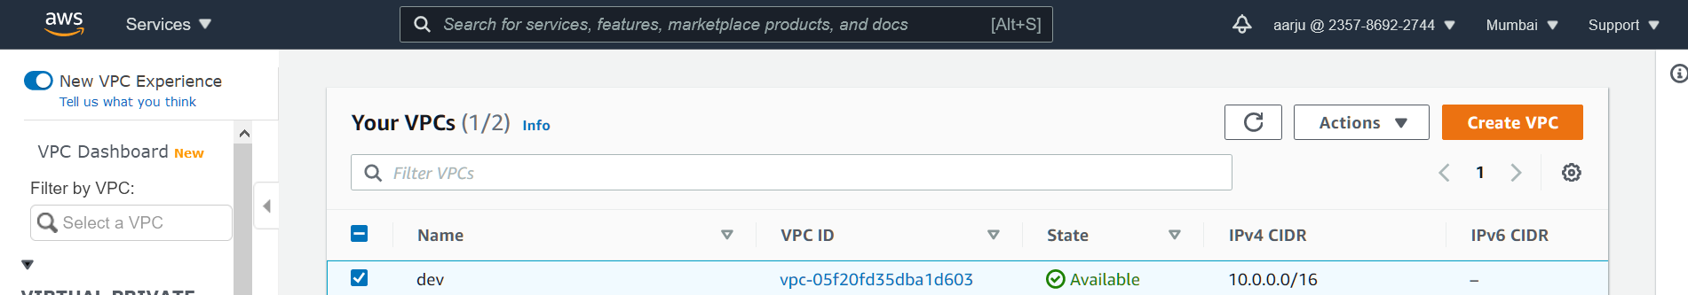

Created a subnet with /24 cidr

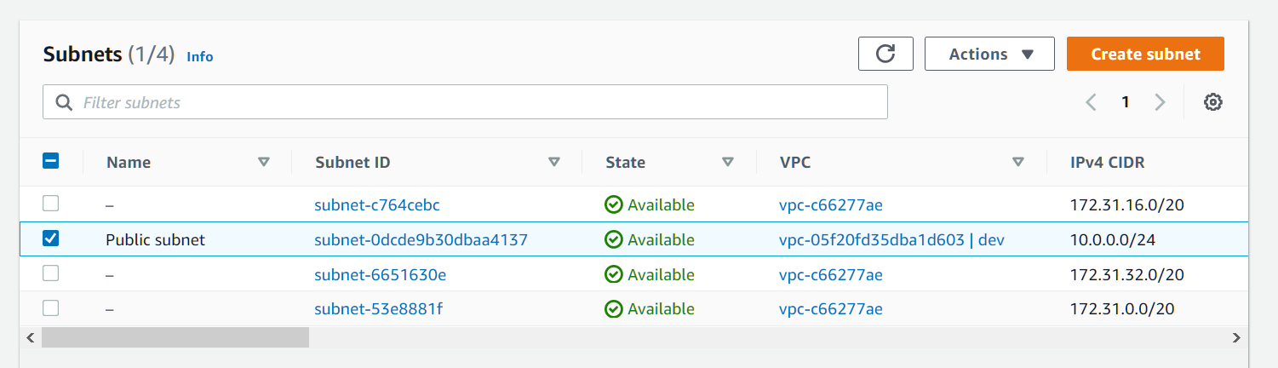

Change route tables

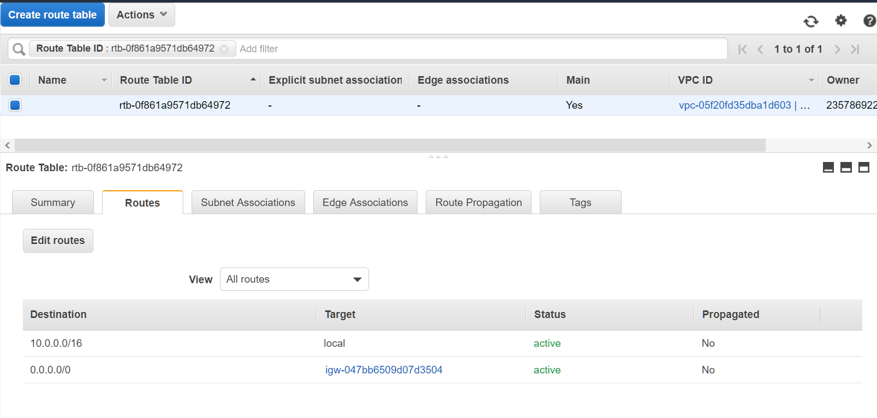

Launched a new server

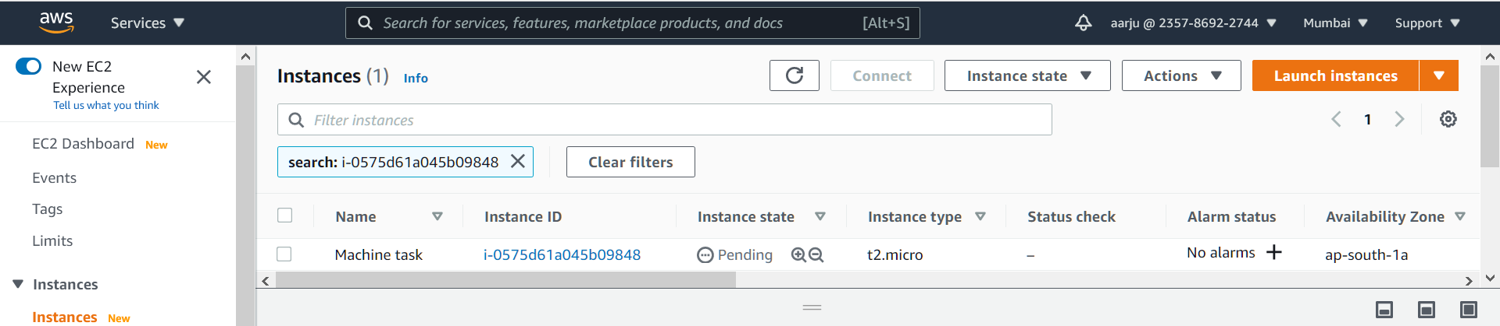

Security group

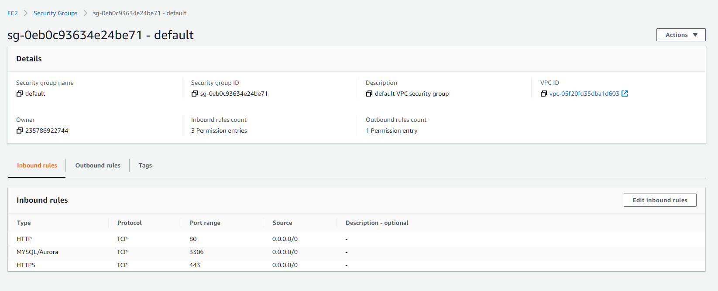

Changed server name



Added user

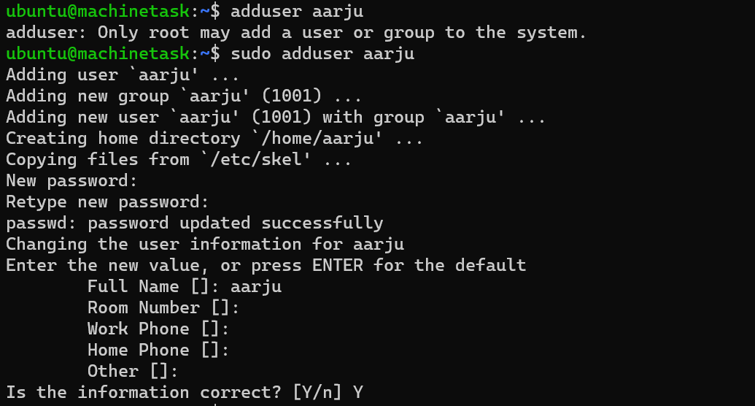



**SSH KEY - Not to be shared**

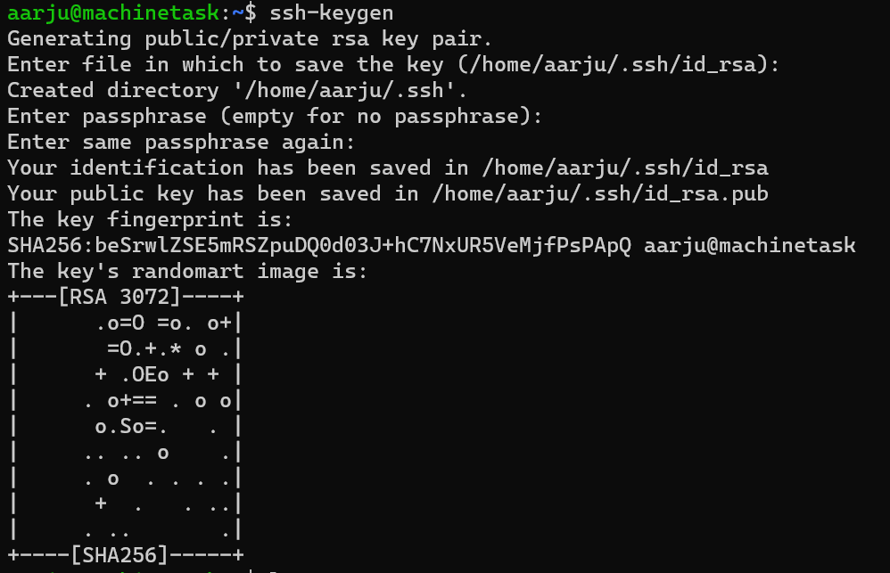



**A running ec2 with jdk and java application deployed using Dockerfile**

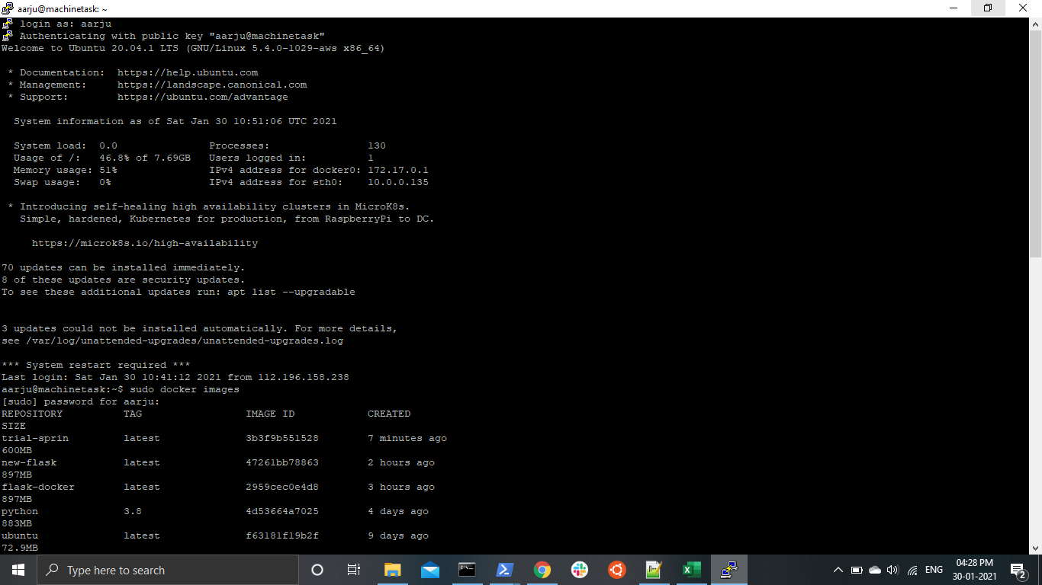

The elastic IP on the EC2 instance attached with EC2 machinetask instance

